**UNIVERSITY INSTITUTE OF TECHNOLOGY**

**BARKATULLAH UNIVERSITY, BHOPAL**

**Department of Computer Science & Engineering**

**MINOR PROJECT**

ON

**“ONLINE SHOPPING STORE”**

**Submitted for the partial fulfilment of the requirement for the**

**Award of Degree of**

**Bachelor of Engineering (B.E)**

**Year 2021**

**University Institute of Technology**

**Barkatullah University, Bhopal**

**By**

Yogesh Bamne Pushpendra Jaat Pawan Kumar Bamne Satyabhama Pal

**Under the Guidance**

**of**

**Mr. Madhav Chaturvedi Dr. Divakar Singh**

**Ms. S.Almelu Head of Department**

**CSE Department CSE Department,**

**UIT-BU, Bhopal UIT-BU, Bhopal**

**UNIVERSITY INSTITUTE OF TECHNOLOGY BARKATULLAH UNIVERSITY, BHOPAL**

**Department of Computer Science & Engineering**

**CERTIFICATE**

**YEAR 2021**

This is to certify that Mr.Yogesh Bamne, Mr.Pushpendra Jaat, Mr.Pawan Bamne and Ms.Satyabhama Pal have successfully completed this project work titled “ONLINE SHOPPING STORE” the partial fulfilment of the award of the degree of Bachelor of Engineering in Computer Science & Engineering in the year 2021 from Barkatullah University Institute of Technology, Bhopal.

**Mr.Madhav Chaturvedi Dr.Divakar Singh Dr.N.K.Gaur**

**Ms. S.Almelu Head of Department, Director**

**Project Guide CSE Department, UIT-BU,Bhopal**

**CSE Department UIT-BU,Bhopal**

**UIT-BU,Bhopal**

**DECLARATION**

The research project on “Online Shopping Store” has been undertaken as a partial fulfilment of the requirement for the award of the degree of bachelor of engineering of Barkatullah University Institute of Technology, Bhopal. We hereby declare that this research project is our original work and the analysis and findings are for academic purpose only. This project has not been submitted by the any student earlier to any other institution/University.

Name:

**Yogesh Bamne**

**Pushpendra Jaat**

**Pawan Kumar Bamne**

**Satyabhama Pal**

**Branch: CSE (BE)**

**6thSem**

**ACKNOWLEDGEMENT**

We would like to express our deepest appreciation to all those who provided us the possibility to complete this report.

Before we get into the thick of the thing’s we would like to add a few heartfelt words for the teacher who is part of this project in a numerous way. Teacher who gave us support right from the project idea were convinced.

First of all, we would like to thank our project guide Mr. Madhav Chaturvedi and Ms. S.Almelu for allowing us to undergo this minor project idea. We would also like to pay our sincere regards to our honourable HOD Dr Divakar Singh for providing effective platform and support in the development of this project and finally we would like to render our thanks to our honourable Director Dr. N.K Gaur for his guidance in this project titled “Online Shopping Store”.

Last but not the least we would like to thank our parent and their support and cooperation. Regardless of the source we wish to express our gratitude to those who may have contributed to this work even though anonymously.

Submitted By:-

**Yogesh Bamne**

**Pushpendra Jaat**

**Pawan KumarBamne**

**Satyabhama Pal**

**ABSTRACT**

An online shopping system that permits a customer to submit online orders for items and/or services from a store that serves both walk-in customers and online customers. The online shopping system presents an online display of an order cut off time and an associated delivery window for items selected by the customer. The system accepts the customer's submission of a purchase order for the item in response to a time of submission being before the order cut off time. The online shopping system does not settle with a credit supplier of the customer until the item selected by the customer is picked from inventory but before it is delivered. Therefore, the customer can go online and make changes to the order. In addition, available service windows are presented to the customer as a function of customer selected order and service types and further, the order picking is assigned in accordance with a picker's preference. When ordering goods, many shopping systems provide a virtual shopping cart for holding items selected for purchase. Successive items selected for purchase are placed into the virtual shopping cart until a customer completes their shopping trip. Virtual shopping carts may be examined at any time, and their contents can be edited or deleted at the option of the customer. Once the customer decides to submit a purchase order, the customer may print the contents of the virtual shopping basket in order to obtain a hard copy record of the transaction.

**CONTENTS**

**LIST OF FIGURES**

S.NO Figure No. Figure Name Page No.

1 Fig.4.3 DFD 18

2 Fig.6.1 Home page 23

2 Fig.6.2 Search page 24

3 Fig.6.3 Product Details page 25

4 Fig.6.4 Shopping Cart page 26

5 Fig.6.5 Categories page 28

6 Fig.6.6 Login page 29

7 Fig.6.7 Signup page 29

LIST OF TABLES

S.NO. Table Number Table Name Page Number

1 Table 6.3.1 Product details table 27

**TABLE OF CONTENT**

**LIST OF FIGURES 7**

**LIST OF TABLES 8**

**LIST OF ABBREVIATIONS 10**

###### **CHAPTER 1: INTRODUCTION 11**

###### **CHAPTER 2: SYSTEM REQUIREMENTS 12**

2.1 Functional Requirements 12

2.2 Software Requirements 12

2.3 Hardware Requirements 12

###### **CHAPTER 3: TOOLS AND TECHNOLOGIES 13**

3.1 Django 13

3.2 Visual Studio Code 13

3.3 Postgre SQL 14

3.4 Bootstrap 14

3.5 CSS 14

3.6 HTML 14

3.7 JAVA Script 15

3.8 Python 15

3.9 PyCharm 15

###### **CHAPTER 4: SYSTEM DESIGN AND ARCHITECTURE 16**

4.1 Objectives 16

4.2 Module Description 17

4.3 Data Flow Diagram 18

###### **CHAPTER 5: CODING 19**

###### **CHAPTER 6: TESTING AND SNAPSHOTS 23**

###### 6.1 Functional testing

###### **CHAPTER 7: CONCLUSION 30**

###### **REFERENCES 31**

**LIST OF ABBREVIATION**

1. IDE Integrated Development Environment
2. SQL Structured Query Language
3. CSS Cascading Style Sheets
4. HTML Hypertext Markup Language
5. RAM Random-Access Memory
6. MTV Model-View-Template
7. XML Extensible Markup Language
8. JSON Java Script Object Notation
9. OSS Operations Support System
10. MIT Massachusetts Institute of Technology
11. JS Java Script
12. SSL Secured Socket Layer
13. FAQs Frequently Asked Questions

**CHAPTER 1**

**INTRODUCTION**

Online shopping is a form of electronic commerce which allows consumers to directly buy goods or services from a seller over the Internet using a web browser. Consumers find a product of interest by visiting the website of the retailer directly or by searching among alternative vendors using a shopping search engine, which displays the same product’s availability and pricing at different e-retailers. A typical online store enables the customer to browse the firm’s range of products and services, view photos or images of the products, along with information about the product specifications, features and prices. Online stores typically enable shoppers to use “search” features to find specific models, brands or items.

Online customers must have access to the Internet and a valid method of payment in order to complete a transaction, such as a credit card, a debit card, or a service such as Paypal. For physical products(e.g., books or clothes), the e-retailer ships the products to the customer; for digital products, such as digital audio files of songs or software, the e-retailer typically sends the file to the customer over the Internet.

Advantages of Online Shopping

* Save Time
* Save Fuel
* Save Energy
* Comparison of Prices
* 24/7 Availability
* Hate Waiting in Lines
* Too Ashamed to Buy
* Easy to Search Merchandise You Want to Buy

**CHAPTER 2**

**SYSTEM REQUIREMENTS**

## 2.1 “Functional Requirements”

* The System must provide following functionalities-
* Keeping records of admission of customers.
* Keeping the records of products.
* Keeping the daily sell.
* Storing details about the product it is delivered or not.
* Storing the items selected by the customer in the temporary storage.

## 2.2 “Software Requirements”

* IDE:-PyCharm
* Visual Studio Code
* Python
* Windows Power Shell
* Django
* PostgreSQL
* Bootstrap
* CSS
* HTML
* JAVA Script

## 2.3 “Hardware Requirements”

* Dual core processor
* 1GB RAM or higher
* 512 GB Hard drive or higher

**CHAPTER 3**

**TOOLS AND TECHNOLOGIES**

#### 3.1 “DJANGO”

**Django** is a Python-based free and open-source web framework that follows the model–template–views (MTV) architectural pattern. It is maintained by the Django Software Foundation.

Also included in the core framework are:

* a lightweight and standalone web server for development and testing
* a form serialization and validation system that can translate between HTML forms and values suitable for storage in the database
* a template system that utilizes the concept of Inheritanceborrowed from object-oriented programming
* a caching framework that can use any of several cache methods
* support for middleware classes that can intervene at various stages of request processing and carry out custom functions
* an internal dispatcher system that allows components of an application to communicate events to each other via pre-defined signals
* an internationalization system, including translations of Django's own components into a variety of languages
* a serialization system that can produce and read xml and/or json representations of Django model instances
* a system for extending the capabilities template engine
* an interface to Python's built-in unit test framework

**3.2 “VISUAL STDIO CODE”**

* **Visual Studio Code** is a source-code editor made by Microsoft for Windows, Linux and macOs. Features include support for debugging, syntax highlighting, intelligent code completion, snippets, code refactoring, and embedded Git. Users can change the theme, keyboard shortcuts, preferences, and install extensions that add additional functionality.
* Microsoft has released most of Visual Studio Code's source code on the microsoft/vscode repository of GitHub using the "Code – OSS" name, under the permissive MIT License, while the releases by Microsoft are proprietary freeware.
* In the Stack Overflow 2019 Developer Survey, Visual Studio Code was ranked the most popular developer environment tool, with 50.7% of 87,317 respondents reporting that they use it.
* Visual Studio Code was first announced on April 29, 2015, by Microsoft at the 2015 Build conference. A Preview build was released shortly thereafter.

#### 3.3 “POSTGRE SQL”

* PostgreSQL is an advanced, enterprise-class, and open-source relational database system. PostgreSQL supports both SQL (relational) and JSON (non-relational) querying.
* PostgreSQL is a highly stable database backed by more than 20 years of development by the open-source community.
* PostgreSQL is used as a primary database for many web applications as well as mobile and analytics applications.

#### 3.4 “BOOTSTRAP”

* Bootstrap is a free and open-sourcefront end development framework for the creation of websites and web apps. The Bootstrap framework is built on HTML, CSS, and JavaScript (JS) to facilitate the development of responsive, mobile-first sites and apps.
* Responsive design makes it possible for a web page or app to detect the visitor’s screen size and orientation and automatically adapt the display accordingly; the mobile first approach assumes that Smartphone, tablets and task-specific Mobile apps are employees' primary tools for getting work done and addresses the requirements of those technologies in design.
* Bootstrap includes user interface components, layouts and JS tools along with the framework for implementation. The software is available precompiled or as source code.

#### 3.5 “CSS”

* CSS stands for Cascading Style Sheets
* CSS describes how HTML elements are to be displayed on screen, paper, or in other media
* CSS saves a lot of work. It can control the layout of multiple web pages all at once
* External stylesheets are stored in CSS files

#### 3.6 “HTML”

* HTML stands for Hyper Text Markup Language
* HTML is the standard markup language for creating Web pages
* HTML describes the structure of a Web page
* HTML consists of a series of elements
* HTML elements tell the browser how to display the content
* HTML elements label pieces of content such as "this is a heading", "this is a paragraph", "this is a link", etc.

#### 3.7 “JAVA SCRIPT”

* **JavaScript** (often shortened to **JS**) is a lightweight, interpreted, object-oriented language with first-class functions, and is best known as the scripting language for Web pages, but it's used in many non-browser environments as well. It is a prototype-based, multi-paradigm scripting language that is dynamic, and supports object-oriented, imperative, and functional programming styles.
* JavaScript runs on the client side of the web, which can be used to design / program how the web pages behave on the occurrence of an event. JavaScript is an easy to learn and also powerful scripting language, widely used for controlling web page behaviour.
* JavaScript can function as both a procedural and an object-oriented language. Objects are created programmatically in JavaScript, by attaching methods and properties to otherwise empty objects **at run time**, as opposed to the syntactic class definitions common in compiled languages like C++ and Java. Once an object has been constructed it can be used as a blueprint (or prototype) for creating similar objects.
* JavaScript's dynamic capabilities include runtime object construction, variable parameter lists, function variables, dynamic script creation (via eval), object introspection (via for ... in), and source code recovery (JavaScript programs can decompile function bodies back into their source text).

#### 3.8 “PYTHON”

* Python can be used on a server to create web applications.
* Python can be used alongside software to create workflows.
* Python can connect to database systems. It can also read and modify files.
* Python can be used to handle big data and perform complex mathematics.
* Python can be used for rapid prototyping, or for production-ready software development.

#### 3.9 “PYCHARM”

PyCharm is the most popular IDE used for Python scripting language. This chapter will give you an introduction to PyCharm and explains its features.

PyCharm offers some of the best features to its users and developers in the following aspects −

* Code completion and inspection
* Advanced debugging
* Support for web programming and frameworks such as Django and Flask

**CHAPTER 4**

**SYSTEM DESIGN AND ARCHITECTURE**

#### 4.1 OBJECTIVES

Our crisp is to help retail store owners to sell their products digitally as-easy-as possible.

Online Shopping Store is the solution for retail business men’s to sell their goods online without paying commission’s to third party ecommerce solutions like amazon.

1. Service Or Product Advertising

The main purpose of a business site is to promote company’s product, services or events on the Internet. There are two main aspects to discuss. First, there are websites that don’t directly sell anything but their objective is to create “buzz”or awareness. An example would be, let’s say an event-a trance music performance taking place next month.

1. Providing Product Support and Customer Service

Due to its world-wide nature, the Internet is a flexible structure allowing users to choose from thousands of similar products they are just one click away. What actually makes the difference between similar online businesses are the price and the customer support they provide.

1. Establishing Brand Awareness and Identity

Establishing brand awareness or company identity is an ongoing process with the purpose with the purpose of branding products with memorable names, eye-catching logos and maybe a slogan. In order to establish brand identity, your website must address these elements in a unitary manner.

## 4.2 MODULE DESCRIPTION

The project entitled “Online Shopping Store” mainly broken into following modules.

* 1. Admin module
  2. User module
  3. Purchase module
  4. Payment module
  5. Validation and Security, etc.

These modules are meant to perform different functionality for the Admin end and User end. At the time, I have done with Admin Window and somewhat about user window.

## ADMIN MODULE

* Admin LOGIN using username and password.
* Admin can change the password and need to enter old password then new password with confirm password.
* Admin is one who can add, delete or modified the products.
* And he/she can add CATEGORY, SUBCATEGORY and PRODUCT.
* Admin is the one having overall control of the website.
* Only Admin comes to know about the order placed on the site and ensure the delivery of the product at time.
* **Administrator** of Shopping Cart System has multiple features such as Add, Delete, Update shopping items.

## USER MODULE

* This is a public link of the website used by the user for shopping purpose.
* Firstly, user need to Login the account to order the product from the website if he/she is not register then he/she cannot login firstly need to register the user, Otherwise, he or she (user) can see the products on the site but cannot order them.
* User can select any category wise products.
* Both online payment methods and cash on delivery will be available to make a transaction.

## PURCHASE MODULE

* In this module user selects the ADD TO CART option for purchasing the desired product.
* This module is very important because its main aim to purchase the product or item by the user.

## PAYMENT MODULE

* In this module user enable for select payment options like credit card and after delivery
* The module takes care of the all the secured payments that should happen for the purchases that happens online, so to implement a security algorithm is one of the major concepts of the payment.

## VALIDATION AND SECURITY

* The main challenge for online shopping portals is to provide security for the transactions involved. Customers, usually need to enter their crucial information such as, credit card number, debit card number etc. to buy products. Today, most of the shopping portals make use of Secured Socket Layer (SSL) to transfer crucial data. Existing system was capable of providing a very good end-to-end security. But, it cannot encrypt only a part of information; hence a large cipher text is generated.
* Validation is very important concept for registration the user for valid transactions.

## 4.3 DATA FLOW DIAGRAM

The DFD serve two purposes

* To provide and indicate how data are transform as they move from the system.
* To depict the functions that transforms that data flow

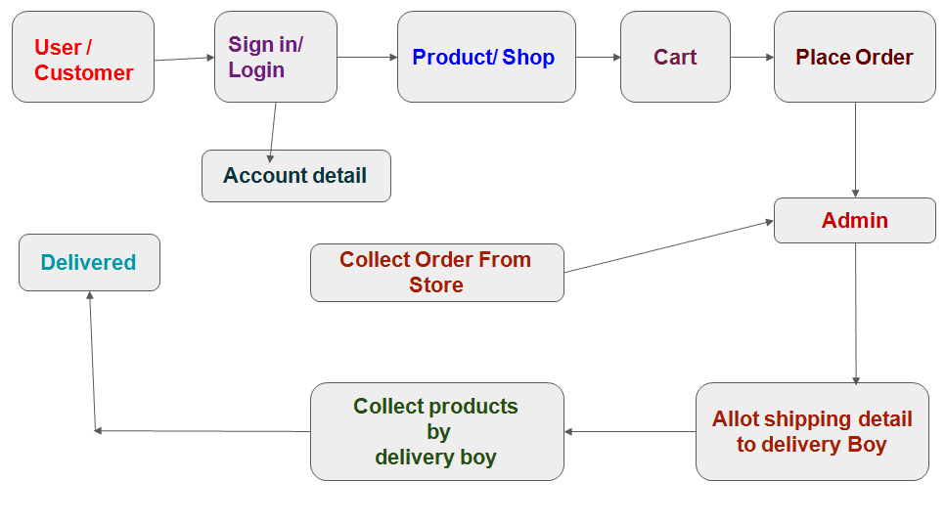

Fig. 4.3

**CHAPTER 5**

**CODING**

{% extends 'header.html' %}

{% block content %}

{% load cart %}

{% load static %}

<!-- Start of Product section 1-->

<div class="fables-index-products large-mb fables-after-overlay py-4 py-md-5 mt-md-5 bg-rules" style="background-image: url(assets/custom/images/index-products-overlay.jpg);"><div class="container z-index position-relative overflow-hidden"><div class="row"><div class="col-12 col-md-7 wow fadeInLeft"><h2 class="fables-second-text-color font-35 font-weight-bold">Our <span class="white-color">Products</span></h2><p class="fables-third-text-color mt-4 mb-md-5"> We have wide range of Fashion Producuts. </p></div><div class="col-12 col-md-5 col-lg-3 text-right offset-lg-2 my-4 my-md-0 mt-md-5 mt-lg-0 text-center"><a href="#" class="btn fables-second-background-color white-color white-color-hover fables-btn-rounded px-5 py-2">View all products</a></div></div><div class="owl-carousel owl-theme dots-0 circle-nav carousel-items-4"><div class="card rounded-0 mb-4 border-light wow fadeIn" data-wow-delay=".4s"><div class="row"><div class="fables-product-img col-12"><imgclass="card-img-top w-100 rounded-0" src="" alt="Fashion"></div><div class="card-body col-12"><h5 class="card-title mx-3"><a href="#" class="fables-main-text-color fables-store-product-title fables-second-hover-color">Fashion</a></h5><p class="card-text fables-fifth-text-color font-15 mx-3">Fashion</p><p class="font-weight-bold fables-second-text-color my-2 mb-3 mx-3"></p><p class="fables-product-info"><a href="#" class="btn fables-second-border-color fables-second-text-color fables-btn-rouned fables-hover-btn-color font-14 px-4 py-2"><span class="fables-iconcart"></span><span class="fables-btn-value">ADD TO CART</span></a></p></div></div></div><div class="card rounded-0 mb-4 border-light wow fadeIn" data-wow-delay=".8s"><div class="row"><div class="fables-product-img col-12"><imgclass="card-img-top rounded-0 w-100" src="" alt="Fashion"></div><div class="card-body col-12"><h5 class="card-title mx-3"><a href="#" class="fables-main-text-color fables-store-product-title fables-second-hover-color">Fashion</a></h5><p class="card-text fables-fifth-text-color font-15 mx-3">Watch</p><p class="font-weight-bold fables-second-text-color my-2 mb-3 mx-3"></p><p class="fables-product-info"><a href="#" class="btn fables-second-border-color fables-second-text-color fables-btn-rouned fables-hover-btn-color font-14 px-4 py-2"><span class="fables-iconcart"></span><span class="fables-btn-value">ADD TO CART</span></a></p></div></div></div><div class="card rounded-0 mb-4 border-light wow fadeIn" data-wow-delay="1.2s"><div class="row"><div class="fables-product-img col-12"><imgclass="card-img-top rounded-0 w-100" src="" alt="Fashion"><div class="fables-img-overlay"></div></div><div class="card-body col-12"><h5 class="card-title mx-3"><a href="#" class="fables-main-text-color fables-store-product-title fables-second-hover-color">Fashion</a></h5><p class="card-text fables-fifth-text-color font-15 mx-3">Fashion</p><p class="font-weight-bold fables-second-text-color my-2 mb-3 mx-3"></p><p class="fables-product-info"><a href="#" class="btn fables-second-border-color fables-second-text-color fables-btn-rouned fables-hover-btn-color font-14 px-4 py-2"><span class="fables-iconcart"></span><span class="fables-btn-value">ADD TO CART</span></a></p></div></div></div><div class="card rounded-0 mb-4 border-light wow fadeIn" data-wow-delay="1.6s"><div class="row"><div class="fables-product-img col-12"><imgclass="card-img-top rounded-0 w-100" src="" alt="Fashion"><div class="fables-img-overlay"></div></div><div class="card-body col-12"><h5 class="card-title mx-3"><a href="#" class="fables-main-text-color fables-store-product-title fables-second-hover-color">Fashion</a></h5><p class="card-text fables-fifth-text-color font-15 mx-3">Fashion</p><p class="font-weight-bold fables-second-text-color my-2 mb-3 mx-3"></p><p class="fables-product-info"><a href="#" class="btn fables-second-border-color fables-second-text-color fables-btn-rouned fables-hover-btn-color font-14 px-4 py-2"><span class="fables-iconcart"></span><span class="fables-btn-value">ADD TO CART</span></a></p></div></div></div><div class="card rounded-0 mb-4 border-light"><div class="row"><div class="fables-product-img col-12"><imgclass="card-img-top rounded-0 w-100" src="" alt="Fashion"></div><div class="card-body col-12"><h5 class="card-title mx-3"><a href="#" class="fables-main-text-color fables-store-product-title fables-second-hover-color">Fashion</a></h5><p class="card-text fables-fifth-text-color font-15 mx-3">Fashion</p><p class="font-weight-bold fables-second-text-color my-2 mx-3"></p><p class="fables-product-info"><a href="#" class="btn fables-second-border-color fables-second-text-color fables-btn-rouned fables-hover-btn-color font-14 px-4 py-2"><span class="fables-iconcart"></span><span class="fables-btn-value">ADD TO CART</span></a></p></div></div></div></div></div></div><!-- /End of Product Section 1 -->  
<!-- Start Products section 2 --><div class="container-fluid my-4 my-md-5"><div class="row"><div class="col-12 col-lg-2 p-0"><div class="text-center fables-main-background-color fables-sqr-rotation fables-second-border-color"><div class="text-rotate"><h2 class="text-white font-25">Our <br><span class="white-color font-40 bold-font mt-2 d-block">Products</span></h2><p class="fables-third-text-color mt-4 mb-3 mb-lg-5"> Trending Products </p></div></div></div><div class="col-12 col-lg-10 p-0"><div class="fables-index-products fables-after-overlay py-3 py-lg-5 pr-md-4 pl-md-5 bg-rules sm-index-products"><div class="container z-index position-relative"><div class="row"><div class="col-12 col-lg-10 offset-lg-2"><div class="owl-carousel owl-theme dots-0 carousel-items-3 circle-nav mt-lg-4 mb-lg-5" id="blog-slider"><div class="card rounded-0 border-light wow fadeIn mb-4 mb-lg-0" data-wow-delay=".4s"><div class="row"><div class="fables-product-img col-12"><imgclass="card-img-top rounded-0 w-100" src="" alt="Fashion"></div><div class="card-body col-12"><h5 class="card-title mx-3"><a href="#" class="fables-main-text-color fables-store-product-title fables-second-hover-color">Fashion</a></h5><p class="card-text fables-fifth-text-color fables-store-product-details mx-3 store-card-text">Watch</p><p class="fables-product-price fables-second-text-color my-2 mx-3 semi-font"></p><p class="fables-product-info my-2"><a href="#" class="btn fables-second-border-color fables-second-text-color fables-btn-rouned fables-hover-btn-color font-15"><span class="fables-iconcart"></span><span class="fables-btn-value">ADD TO CART</span></a></p></div></div></div><div class="card rounded-0 border-light wow fadeIn mb-4 mb-lg-0" data-wow-delay=".8s"><div class="row"><div class="fables-product-img col-12"><imgclass="card-img-top rounded-0 w-100" src="" alt="Fashion"></div><div class="card-body col-12"><h5 class="card-title mx-3"><a href="#" class="fables-main-text-color fables-store-product-title fables-second-hover-color">Fashion</a></h5><p class="card-text fables-fifth-text-color fables-store-product-details mx-3 store-card-text">Fashion</p><p class="fables-product-price fables-second-text-color my-2 mx-3 semi-font"></p><p class="fables-product-info my-2"><a href="#" class="btn fables-second-border-color fables-second-text-color fables-btn-rouned fables-hover-btn-color font-15"><span class="fables-iconcart"></span><span class="fables-btn-value">ADD TO CART</span></a></p></div></div></div><div class="card rounded-0 border-light wow fadeIn mb-4 mb-lg-0" data-wow-delay="1.2s"><div class="row"><div class="fables-product-img col-12"><imgclass="card-img-top rounded-0 w-100" src="" alt="Fashion"></div><div class="card-body col-12"><h5 class="card-title mx-3"><a href="#" class="fables-main-text-color fables-store-product-title fables-second-hover-color">Fashion</a></h5><p class="card-text fables-fifth-text-color fables-store-product-details mx-3 store-card-text">Fashion</p><p class="fables-product-price fables-second-text-color my-2 mx-3 semi-font"> 0</p><p class="fables-product-info"><a href="#" class="btn fables-second-border-color fables-second-text-color fables-btn-rouned fables-hover-btn-color font-15"><span class="fables-iconcart"></span><span class="fables-btn-value">ADD TO CART</span></a></p></div></div></div><div class="card rounded-0 border-light wow fadeIn mb-4 mb-lg-0" data-wow-delay="1.6s"><div class="row"><div class="fables-product-img col-12"><imgclass="card-img-top rounded-0 w-100" src="" alt="Fashion"></div><div class="card-body col-12"><h5 class="card-title mx-3"><a href="#" class="fables-main-text-color fables-store-product-title fables-second-hover-color">Fashion</a></h5><p class="card-text fables-fifth-text-color fables-store-product-details mx-3 store-card-text">Fashion</p><p class="fables-product-price fables-second-text-color my-2 mx-3 semi-font"></p><p class="fables-product-info my-2"><a href="#" class="btn fables-second-border-color fables-second-text-color fables-btn-rouned fables-hover-btn-color font-15"><span class="fables-iconcart"></span><span class="fables-btn-value">ADD TO CART</span></a></p></div></div></div></div><a href="#" class="btn white-color font-18 all-index-products fables-second-hover-color border-0 p-0 position-absolute d-block pt-4 pt-md-0 z-index "><span class="underline">View all products</span><span class="fables-iconarrow-light ml-2 font-13"></span></a></div></div></div></div></div></div></div><!-- End Products section 2 -->  
<!-- /End page content --><!-- Start Footer Background Image --><div class="fables-footer-image fables-after-overlay white-color py-4 py-lg-5 bg-rules"><div class="container"><div class="row"><div class="col-12 col-md-8 offset-md-2 col-lg-6 offset-lg-3 mt-2 mb-5 text-center"><h2 class="font-30 semi-font mb-5">Newsletter</h2><form class="form-inline position-relative"><div class="form-group fables-subscribe-formgroup"><input type="email" class="form-control fables-subscribe-input fables-btn-rouned" placeholder="Your Email"></div><button type="submit" class="btn fables-second-background-color fables-btn-rouned fables-subscribe-btn">Subscribe</button></form></div><div class="col-12 col-lg-4 mb-4 mb-lg-0"><a href="#" class="fables-second-border-color border-bottom pb-3 d-block mb-3 mt-minus-13"><imgsrc="" alt="fables template"></a><p class="font-15 fables-third-text-color">eCom is the Online Fashion Store, serving men's , women's latest fastion products all over India. </p></div><div class="col-12 col-sm-6 col-lg-4"><h2 class="font-20 semi-font fables-second-border-color border-bottom pb-3">Contact us</h2><div class="my-3"><h4 class="font-16 semi-font"><span class="fables-iconmap-icon fables-second-text-color pr-2 font-20 mt-1 d-inline-block"></span> Address Information</h4><p class="font-14 fables-fifth-text-color mt-2 ml-4">Berasia , 463106</p></div><div class="my-3"><h4 class="font-16 semi-font"><span class="fables-iconphone fables-second-text-color pr-2 font-20 mt-1 d-inline-block"></span> Call Now </h4><p class="font-14 fables-fifth-text-color mt-2 ml-4">+91 9179045012</p></div><div class="my-3"><h4 class="font-16 semi-font"><span class="fables-iconemail fables-second-text-color pr-2 font-20 mt-1 d-inline-block"></span> Mail </h4><p class="font-14 fables-fifth-text-color mt-2 ml-4">support@ecom.com</p></div></div><div class="col-12 col-sm-6 col-lg-4"><h2 class="font-20 semi-font fables-second-border-color border-bottom pb-3 mb-3">EXPLORE OUR SITE</h2><ul class="nav fables-footer-links"><li><a href="about1.html">About Us</a></li><li><a href="contactus1.html">Contact Us</a></li></ul></div></div></div></div><div class="copyright fables-main-background-color mt-0 border-0 white-color"><ul class="nav fables-footer-social-links just-center fables-light-footer-links"><li><a href="#" target="_blank"><iclass="fab fa-google-plus-square"></i></a></li><li><a href="#" target="_blank"><iclass="fab fa-facebook"></i></a></li><li><a href="#" target="_blank"><iclass="fab fa-instagram"></i></a></li><li><a href="#" target="_blank"><iclass="fab fa-pinterest-square"></i></a></li><li><a href="#" target="_blank"><iclass="fab fa-twitter-square"></i></a></li><li><a href="#" target="_blank"><iclass="fab fa-linkedin"></i></a></li></ul><p class="mb-0">Copyright © eCom 2021. All rights reserved.</p>  
</div><!-- /End Footer 2 Background Image -->{% endblock %}

**CHAPTER 6**

**TESTING AND SNAPSHOTS**

Below, we have listed important segments and test cases for Online shopping store website testing.

### 6.1) Homepage – Hero Image

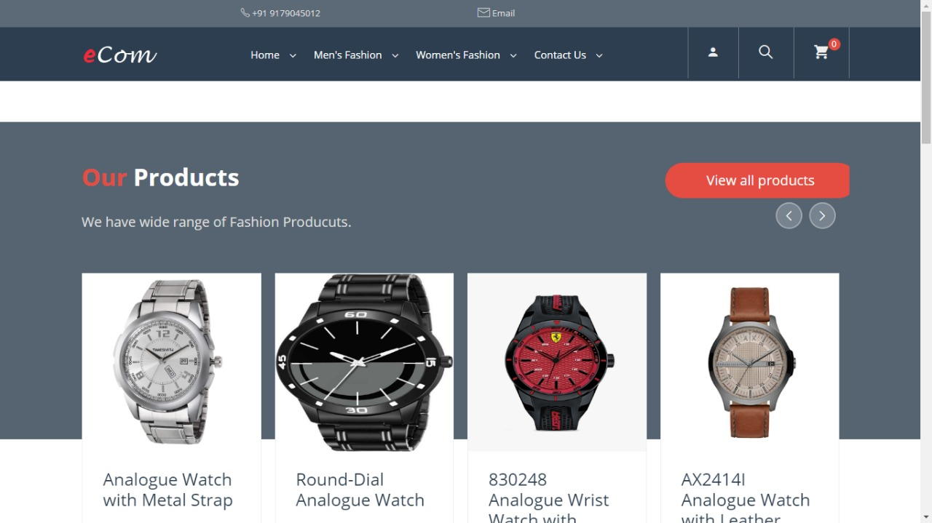Homepages of retail sites are busy. They have a lot going on. But almost all of them have a Hero Image:

Fig.6.1

This is the kind of the clickable image (a slideshow of sorts) that occupies the majority of the page.

**The following are a few things to test:**

* Is it going to auto scroll?
* If yes, at what interval will the image be refreshed?
* When the user hovers over it, is it still going to scroll to the next one?
* Can it be hovered on?
* Can it be clicked on?
* If yes, is it taking you to the right page and right deal?
* Is it loading along with the rest of the page or loads last in comparison to the other elements on the page?
* Can the rest of the content be viewed?
* Does it render the same way in different browsers and different screen resolutions?

### 6.2) Search

Search algorithms are very important for the success of a retail site because we can’t always place what the users want to see right in front of their eyes.

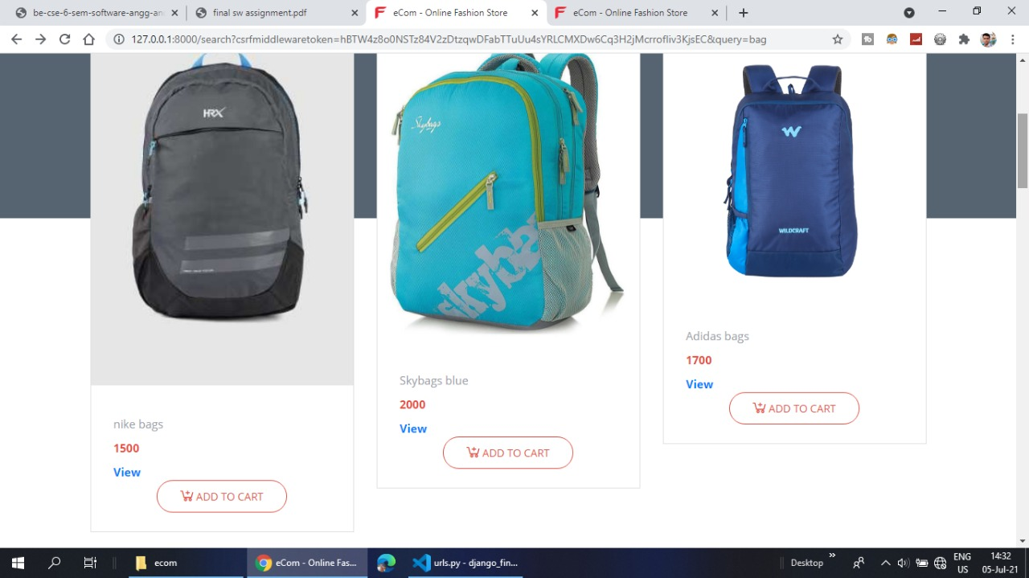

Fig.6.2

**Common tests are:**

* Search based on the Product name, brand name, or something more broadly, the category. **For example** Camera, Canon EOS 700D, electronics, etc.
* Search Results have to be relevant
* Different sort options have to be available- based on Brand, Price, and Reviews/ratings etc.
* How many results to display per page?
* For multi-page results, are there options to navigate to them
* Also, search happens in many places. Please take the search drilling down into multiple levels into consideration when validating this functionality. ***For example:*** When I search on the home page, I might see something like this:

### 6.3) Product Details Page

Once a user finds a product either through search or by browsing or by clicking on it from the homepage, the user will be taken to the product information page.

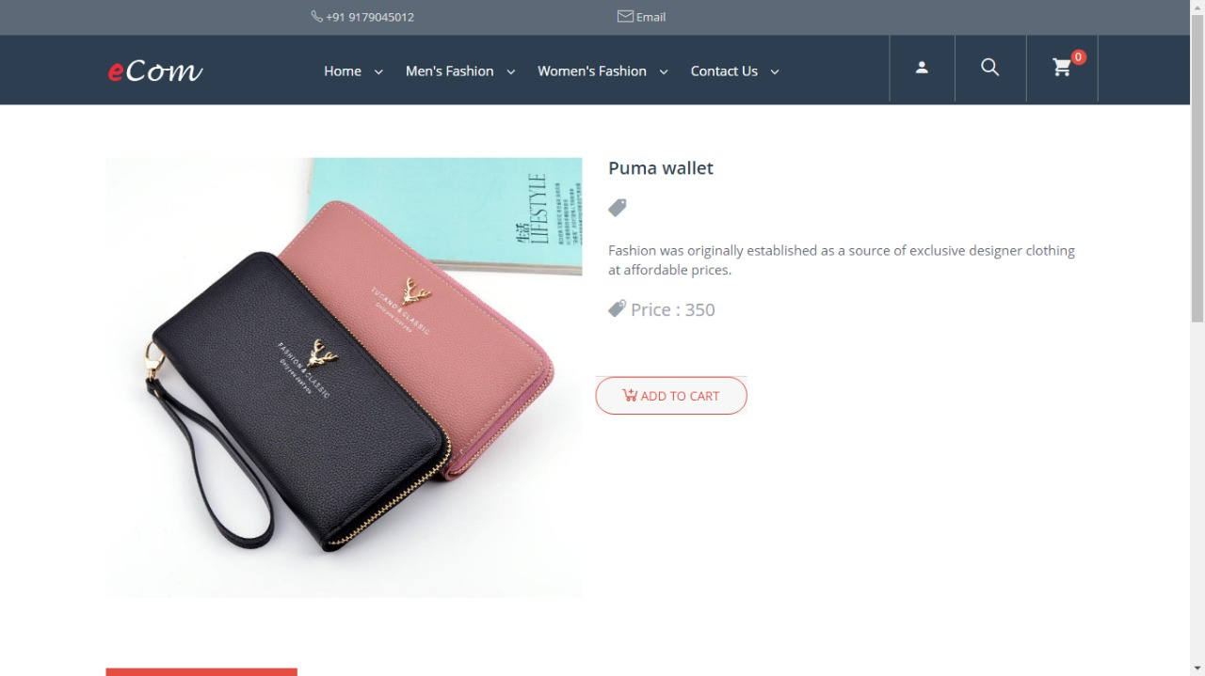

Fig.6.3

**Check:**

* Image or images of the product
* Price of the product
* Product specifications
* Reviews
* Check out options
* Delivery options
* Shipping information
* In-stock/Out of stock
* Multiple colour or variations options
* Breadcrumb navigation for the categories (highlighted in Red below). If navigation such as that is displayed, make sure every element of it is functional.

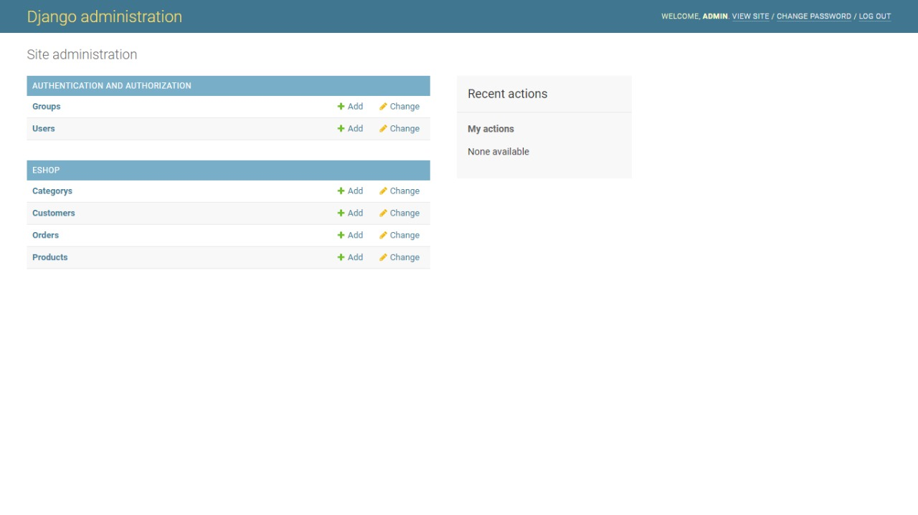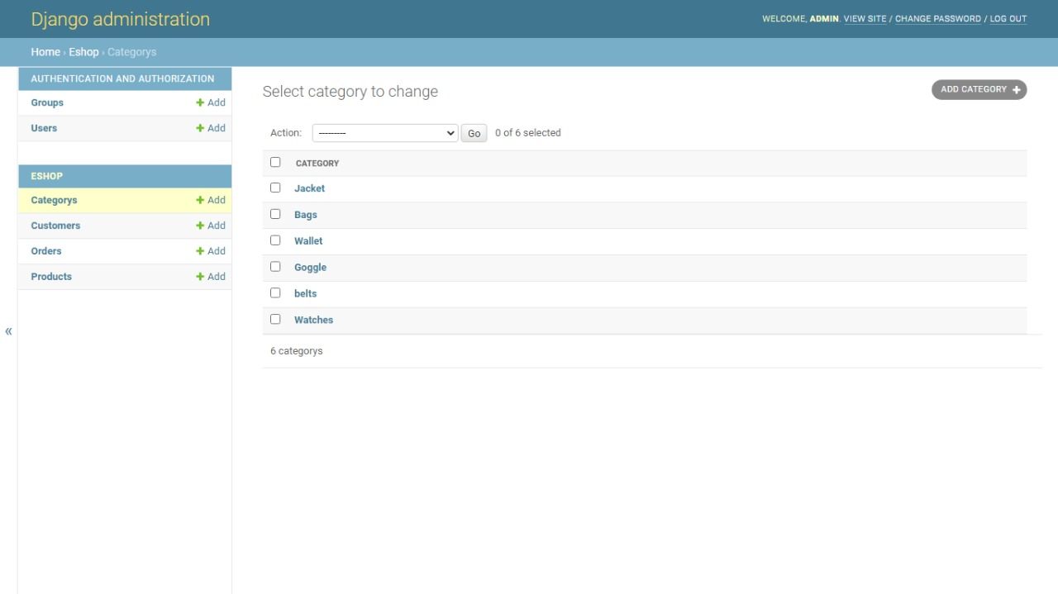Fig.6.3.1

Fig.6.3.2

### 6.4) Shopping Cart

This is the penultimate stage before the user commits to the purchase.

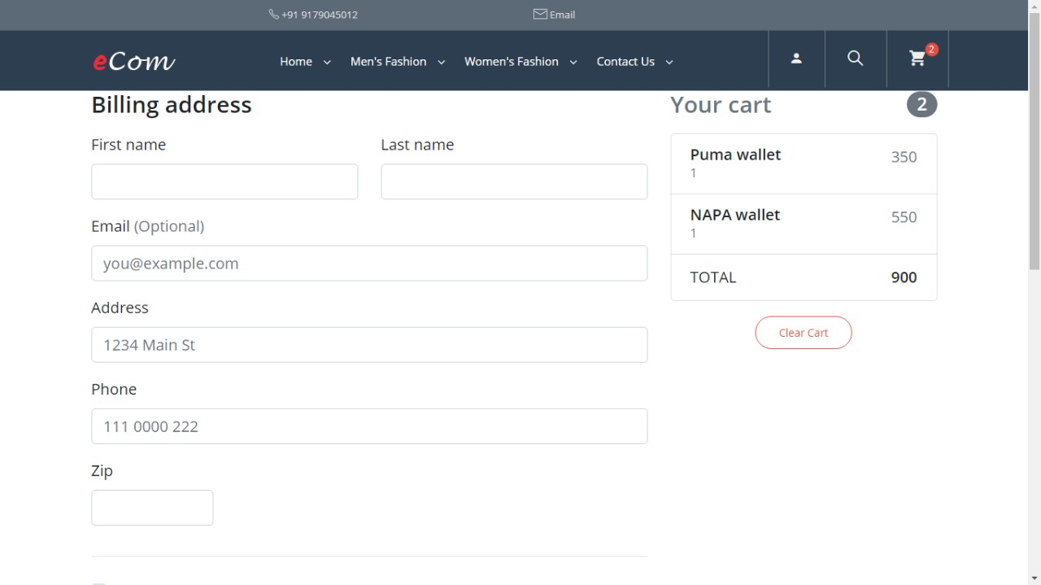

Fig.6.4

**Test the following:**

* Add items to the cart and continue shopping
* If the user adds the same item to the cart while continuing to shop, the item count in the shopping cart should get incremented
* All items and their totals should be displayed in the cart
* Taxes as per location should be applied
* A user can add more items to the cart- total should reflect the same
* Update the contents added to the cart- total should reflect that too
* Remove items from the cart
* Proceed to checkout
* Calculate Shipping costs with different shipping options
* Apply coupons
* Don’t check out, close the site, and come back later. The site should retain the items in the cart

### 5) Payments

* Check different payment options
* If allowing check out as Guest, simply finish the purchase and provide an option to register at the end
* Returning customers – Login to check out
* User sign up
* If storing customer Credit card or any other financial information, perform security testing around this to make sure it is secure.(PCI compliance is a must)
* If the user is signed up for a long time, make sure the session is timed out or not. Every site has a different threshold. For some, it is 10 minutes. For some, it might be different.
* Emails/Text confirmation with the order number generated

### 6) Categories/Featured Products/Related or Recommended Products

The most popular FAQ I get from E-commerce testers is: Do I have to test every category/every product?

The answer is NO.

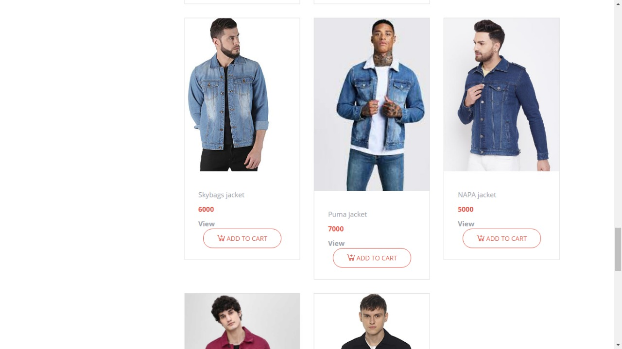Fig.6.5If you are a returning customer you will be shown some recommended products on the home page or in your shopping cart.

Since these are dynamic elements, the best way to test these parts of the application is to test the algorithm based on which these sections are populated.

Check your Data mining/BI systems and check from the backend the queries that populate these sections.

### 7) After-Order Tests

**Check:**

* Change the Order
* Cancel the Order
* Track the Order
* Returns

### 8) Other Tests

* Login
* FAQs
* Contact Us page
* Customer Service page etc.

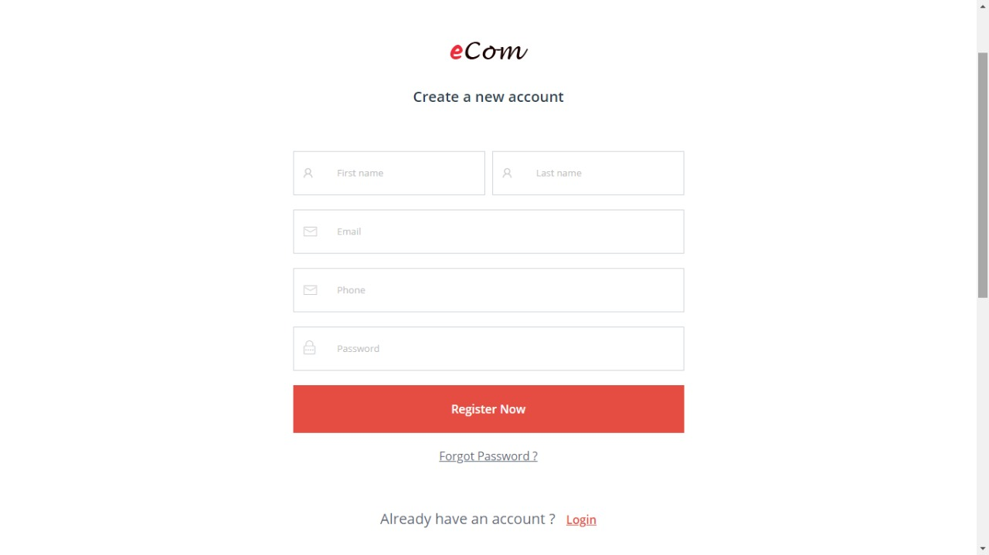

Fig.6.6

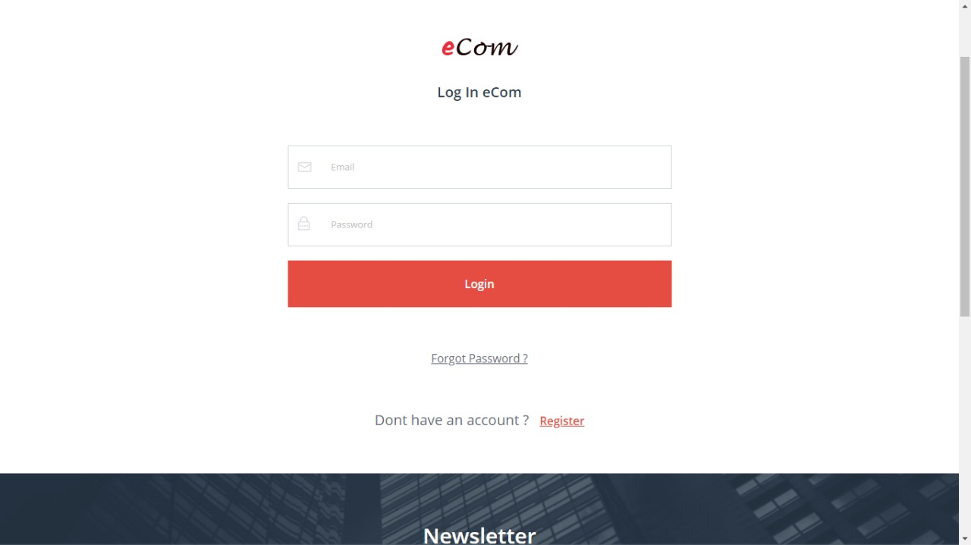

Fig.6.7

**CHAPTER 7**

**CONCLUSION**

Technology has made significant progress over the years to provide consumers a better online shopping experience and will continue to do so for years to come.  With the rapid growth of products and brands, people have speculated that online shopping will overtake in-store shopping.  While this has been the case in some areas, there is still demand for brick and mortar stores in market areas where the consumer feels more comfortable seeing and touching the product being bought.  However, the availability of online shopping has produced a more educated consumer that can shop around with relative ease without having to spend a large amount of time.  In exchange, online shopping has opened up doors to many small retailers that would never be in business if they had to incur the high cost of owning a brick and mortar store.  At the end, it has been a win-win situation for both consumer and sellers.

**REFERENCES**

* https://getbootstrap.com/
* https://www.djangoproject.com/
* https://www.postgresql.org
* https://www.youtube.com/watch?v=ta9kgf15i20&t
* https://www.youtube.com/playlist?list=PLdBwVRHjcI__NWxctXUSLz1Gg2Mb-B-O-
* https://www.youtube.com/playlist?list=PLu0W_9lII9ah7DDtYtflgwMwpT3xmjXY9